Name _________________________________________
Capitalism vs. Marxism
Adam Smith
________________________________________________________________________________________________________________________________________________________________________________________________________________________________________________________________________
Karl Marx
______________________________________________________________________________________________________________________________________________________________________________________________________________________________________________________________________________
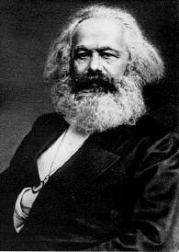
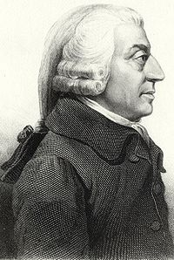

Capitalist Ideas | Connection to your life | Connection to your life | Marxist Ideas
Progress results when Individuals follow their own self-interest. |  |  | All great movements in history are the result of an economic class struggle. The Industrial Revolution intensified the class struggle.
Businesses follow their own self-interest when they compete with one another for the consumer’s money. |  |  | The “haves” take advantage of the “have-nots.” Workers are exploited by employers
Each producer tries to provide goods and services that are better and less expensive than those of their competitors. |  |  | The community or state should own property and the means of production.
Consumers compete with one another to purchase the best goods at the lowest prices. |  |  | The capitalist system will eventually destroy itself. The state will wither away as a classless society develops.
Market economy aims to produce the best products and the lowest prices. |  |  | The labor of workers creates profits for employers.
Government should not interfere in the economy. |  |  | Distribute goods according to each person’s needs.

