Using the Individual you selected, research their life and create a bio cube that addresses the information in each of the boxes. When completed see Ms. Burton to save and print

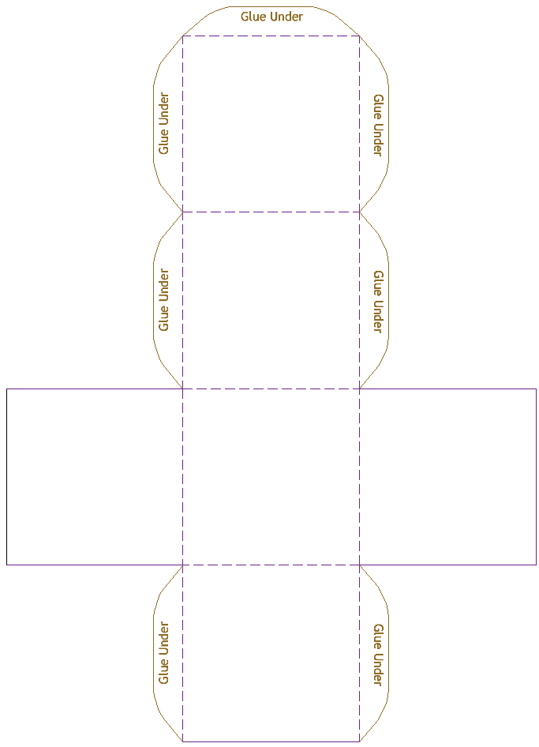
Picture
Quote

Your name
Personal Background
Challenges Faced
Name of Person
Profession
Birth date
Death date
What are they best known for?
Three examples.

