Lord of the Flies

**Character Transformation in *Lord of the Flies***

***Before and After Character Study of Jack, Ralph, & Piggy***

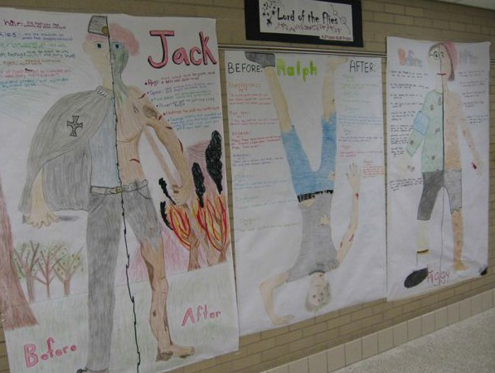

**Step One**: Get assigned character from the teacher, gather your supplies, and find a spot in the room to meet with your group.

**Step Two**: Draw your character life-size on the sheet of paper with TWO HALVES! (Tip: Trace a group member’s silhouette on the paper in pencil as a starting point and then make adjustments to fit character.) The left half should be their character as they were when they first began on the island.

The right side should be their character as they have transformed on the island.

**Step Three:** On the left side, neatly write in a character description and a quote for before and on the right a description of the same element near the end of the book with quotes and page numbers that support it. For example, near the end of the book Piggy’s glasses were broke by Jack. “Jack smacked Piggy’s head. Piggy’s glasses flew off and tinkled on the rocks” (60). Repeat until you have at least 4 strong examples that show changes representing before and after.

**Step Four**: Draw each of those descriptions into your life-size picture.

**Step Five**: Color in your character (NEATLY!), add final details and put your names in the lower left hand side.

**Step Six:** Draw at least three symbols that represent your character. For each symbol, write what the symbol represents.

# Ways to split up the work:

Member 1- Trace one group member to be the template for the drawing. Member 2-While one is drawing, another can start coloring in.

Member 3 and 4-While one is drawing/coloring, the other members should be looking for character descriptions and quotes/page numbers.

# Grading= 55pts. (group grade)

* At least 4 descriptions with quote support for each side (before and after). (16pts.)

*Creativity, color, and effort in the drawing (10pts.)

*Symbols and descriptions (9pts.)

*Group effectiveness and on task behavior (10pts.)

*Presentation of Poster (10pts.)

**NOTE:** Groups who are not on task and cooperative (meaning - all members are working together and are focusing on THEIR group rather than the other groups in the class) will be excluded from presenting. The group will lose the 10 presentation points as well as the 10 effectiveness/on task behavior points.